**Data Blending**

**Calculations in Tableau**

**Statement:**

Using data blending, create a report on Students’ Performance in Reading and Aptitude Tests as both the data are captured on different systems.

(Refer to the dataset: Aptitude Score.xslx and Student Academic Information.xslx)

**Solution:**

**Data Blending in Tableau**

Data Blending allows us to combine multiple sources in a single view. Instead of joining the data at the row level, data blending sends separate queries to separate data sources and aggregates the result to a common level back in Tableau.

**Step 1:** Connect to “Microsoft Excel” 🡪” Student Academic Information data source”🡪Open

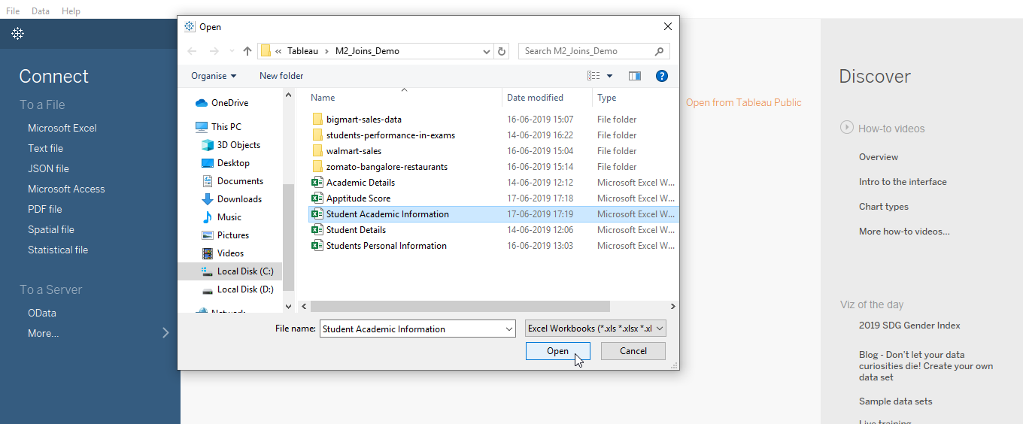

Data from “Student Academic Information”

**Step 2:** To add a new data source, click on “Data”🡪 “New Data Source” 🡪 ” Microsoft Excel” 🡪 “Select Aptitude Score” 🡪 “Open.”

**Step 3:** Click on the sheet tab to start building your view.

**Step 4:** In the Data pane, click the data source that you want to designate as the primary data source. Here, the Aptitude score is selected as the primary data source.

Fields used in the view from data sources that are not the primary data source or active links automatically designate subsequent data sources as the secondary data source; in this case, “Student Academic Information” is the secondary data source.

Now, you can integrate the data from both sources based on a common dimension (Race in this case). Note that a small link image appears next to the dimension – Race. This indicates the common dimension between the two data source

**Step 5:** Create a bar chart by dragging:

* Aptitude Score and Reading Score to the Column shelf
* Race and Gender to the Row shelf

This chart shows how the Scoring ratio varies for each Race and Gender in Aptitude and Reading Tests.